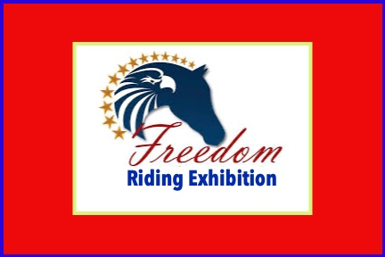
Set up and run like a FUN SHOW, with the FREEDOM to enjoy all classes, regardless of traditional academy rule limitations.

Because we are hosting an EXHIBITION, Academy riders can show in all classes without losing their academy eligibility. They must ride in their academy clothes or barn t-shirts. Full suits are reserved for Show Riders. Judging will not be influenced by clothing choice.

Glitter suggested for ALL horses!

Judge: David Earehart
Lone Hickory Arena
1950 Bethel Church Rd, Yadkinville, NC 27055
10:00 am start time
Exhibition sponsored by Cash Lovell Stables & Riding Academy

- STICK HORSE and FREEDOM PARADE. Real horses welcome. (Prize for most patriotic)
- Walk Only, Open to all
- Rescue Horse GAYP
- Open Leadline, all ages
- Novice Rider WT/J all disciplines
- Open GAYP
- Novice Horse, GAYP, all disciplines
- WT/J Open, all disciplines
- The Ms. Parker Says class, WT
- Academy Showmanship WT 15 & Up
- Academy Showmanship WT ON LEAD, all ages
- Academy Equitation WT 15 & UP
- Academy Equitation WT ON LEAD, all ages
- Academy Showmanship WT, 13 & 14 year olds
- Hunt Seat Open GAYP
- Academy Showmanship WT, 9 & 10 year olds
- Hunt Seat Open
- Academy Showmanship WT, 7 & 8 year olds
- Academy Showmanship WT, 6 & Under
- Hunt Seat Equitation WT, 13 & Over
- Academy Showmanship WTC, all ages
- Hunt Seat Equitation WT, 12 & Under
- Academy Equitation WT, 13 & 14 year olds
- Command Class, WT, all ages, all disciplines
- Academy Equitation WT, 9 & 10 year olds

- Just Ride GAYP, all ages, all disciplines
- Academy Equitation WT, 7 & 8 year olds
- Academy Equitation WT, 6 & Under
- Academy Equitation WTC, all ages
- Open Equitation WTC, all disciplines
- The In-Hand Glitterama Class (How many sparkles can one horse wear?)
- To Pattern or Not To Pattern Equitation Class, WTC pattern and WT pattern. Will be judged separately. WTC riders go first.

RULES:

Sportsmanship is paramount.
Kindness to all animals and people is mandatory.
Cheering loudly is encouraged.
Having fun is guaranteed!

A note on Covid-19.
Everyone will be asked to follow physical distancing suggestions. Masks are suggested but not mandatory. Each barn will be given a special section in the bleachers. Hand washing is suggested A LOT. Common sense is needed to keep everyone safe and healthy!

Food will be available, cooked by Lone Hickory Arena’s owners. They will be wearing masks and following all suggested serving guidelines.

For all non-owned CLS horses, class fees are $15 each.

Everyone rides at his or her own risk.

Limited stalls are available. Classes can be added or changed. Contact Parker Lovell ahead for details. 336-971-9388 or parker@cashlovellstables.com

